Short-beaked common dolphin (Delphinus delphis) diet: amount and composition.

Short-beaked common dolphin (Delphinus delphis) is the main species of cetacean in the Iberian Peninsula. Due to the relatively high abundance of common dolphins in this region and the high food intake needed by marine mammals, dolphins might have an important impact in the populations of their main prey species and in the ecosystem. The fourth most abundant prey species of common dolphin in the Iberian Peninsula is the European hake (Merluccius merluccius) (Santos et al., 2013). Although hake is recorded in the diet of various predators such anglerfish (Lophius spp.), hake itself (Preciado et al., 2008) and cetaceans as bottlenose dolphin (Tursiops truncatus) (Santos et al., 2013), total amount consumed by common dolphins may be enough to affect of the stock dynamics of hake.

Since European hake is one of the most important fishery resource for the Iberian Peninsula, competition between marine mammals and fisheries should be taken into account. Construction of multiespecies models allow us to know the impact of common dolphin in the ecosystem and in particular their interaction with the hake population and fisheries. To integrate common dolphin in multiespecies models besides knowing their biological parameters and life histoty, is necessary to have good information on the composition of their diet and energetic requirements.

Proportion of hake in the common dolphin diet

The diet of common dolphin has been described from the examination of the stomach content of animals stranded and bycaught in the Iberian Peninsula, both in Galicia (NW Spain) (Santos et al., 2007; 2013) and in Portugal (Silva, 1999). 514 dolphins were analysed from 1991 to 2008 from Galician coast and 50 from 1987 to 1997, in Portugal. Hake proportion in weight of the total stomach content were 5.7% (4.3-7.3) in the Galician dolphins and 2% (1-4.1) in the Portuguese dolphins. The estimated importance of each prey category by weight was also converted into energy values based on energy density data provided by Spitz et al. (2010) . The energy which represents hake in 1 kg of food for each dolphin is 211.3 kj/kg for Galicia (159.1-270.8) and 77.7 kj/kg for Portugal (38.6-162.7).

Daily food intake

Daily energy intake for common dolphin has been approximated in the literature based either on experimental studies (e.g. respirometry), relationships with the basal metabolic rate (BMR), or direct estimates of food consumption in the wild or in captivity. Three indices can be used for estimate energetic consumption for common dolphins, two based only in the dolphin weight: Kastelein et al. (2000) and Innes et al. (1987), and another based in the weight of the dolphin as well, but also in the energetic content of their diet: Kleiber (1947).

Length and weight distribution of the Galician dolphins were used to estimate the energy and food intakes both for the Galician and for the Portuguese dolphins. Only was possible to measure 407 of the 518 dolphins and sexing 491. The lengths ranged from 121 to 240 cm and the corresponding weight was estimated for each of this dolphins by applying previous calculated length-weight relationships based on data collected from several European countries (Pierce et al., 2005). When sex data was available, male and female length-weight relationships were applied, if not, a general model for both sexes was applied. These lengths corresponded to weights ranging from 20.7 to 139.9 kg (average weight = 70.97 kg). Frequencies of the lengths and their corresponding weights showed a normal distribution (see Fig. 1).

The three energy indices give us different figures of daily food intake. While the Kastelein and Innes indices gave the same figures for Galicia and Portugal, 6.49 kg/day (95% CI, 6.38 – 6.59) and 4.82 kg/day (4.71 – 4.94) respectively, the Kleiber index use the energy content of the diet in each region and, due to differences of this, the food intakes obtained were 5.55 kg/day (5.42 – 5.68) for Galicia and 4.38 kg/day (4.27 - 4.48) for Potugal. These values correspond with the mean of the food intakes estimated for all the dolphins analysed and confidence intervals were bootstrapped, based on 1000 runs using the boot and boot.ci commands in the package boot (Canty and Ripley, 2001) in R 2.13.0 (R Development Core Tean 2008)
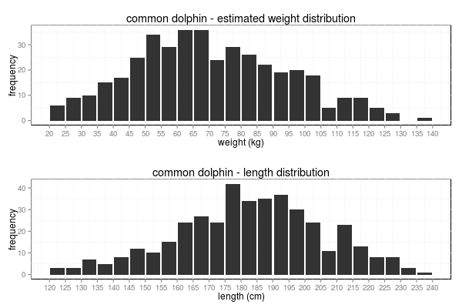
Fig. 1: Estimated weight distribution (upper figure) and length distribution (lower figure) for common dolphins whose stomachs were analysed.

Daily food intake is quite different depending on the index used, therefore, food intake was estimated for all dolphins with the three indices and for the two areas and the resulting values were fitted in a new linear model (Fig. 2). The mean food intake was 5.31 kg/day (5.20 – 5.41) for an average dolphin and the kilograms of food consumed per dolphin kilogram was 0.075 kg (0.073 – 0.076). The linear regression resulted as follows:

whereis the daily food intake of a given dolphin andis the dolphin weight.
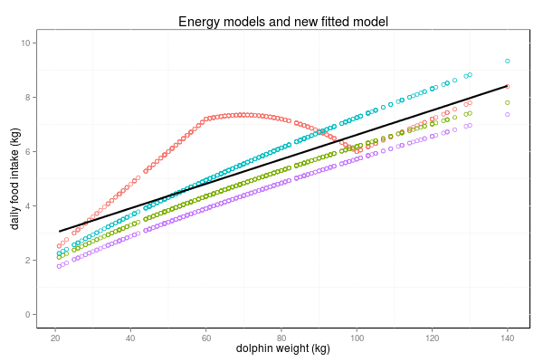
Fig. 2: Daily food intake calculated with the Kastelein index (red dots), with the Innes index (green dots), with the Kleiber index for Galicia (blue dots) and for Portugal (purple dots). The regression model fitted to all these values is represented as a dark line.

Relationship between lengths of dolphins and hakes

The relationship between the length of the dolphins and the length of their preys was analysed. Is expected that the largest dolphins eat larger prey, however, although this occurs to some extent, dolphins are opportunistic and prey on a wide range of lengths. A regression model was fitted to this relationship, the slope was slightly positive but, due to the high dispersion of the data the adjusted R-squared was 0.015. Length estimated of one hake was higher than 60 cm and was removed for the data to be considered an outlier. The resulting regression was as shown below:

whereis the prediction of the hale length andis the dolphin length.

The scatterplot and the fitted regression of this relationship are shown in Fig. 3. Histograms of lengths frequencies are plotted as well both for hake and dolphins. Hake length frequencies are log-normal distributed and the range between 10 and 20 cm comprises more than half of the preyed hakes. Assuming that the dolphins were randomly analysed from the total observed stranded dolphins in the same period, population structure of analysed dolphins will be the same as the one of the total population of dolphins in this area. Therefore, the hake length frequency distribution observed in these stomachs will be the same as the preyed by the total dolphins population.
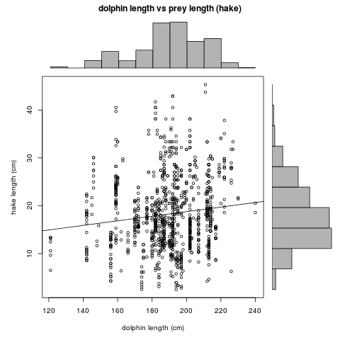
Fig. 3: Relationship between dolphins length with the length of their preys and fitted regression. Histogram of the length dolphins distribution, on the top. Histogram of the length hake distribution, on the right.

Based on these assumptions, hake length distribution in the diet of a given dolphin can be obtained by applying a probability function equal to that observed in the stomach samples, regardless of the length of the dolphin. Probability density function of the length distribution of the hakes found in the total stomaches analysed was calculated applying the non-parametric Kernel density estimation (KDE). Then, a GAM was fitted to the density estimated values in order to create a prediction funtion to estimate the probability of occurrence of each length hake class (Fig. 4).

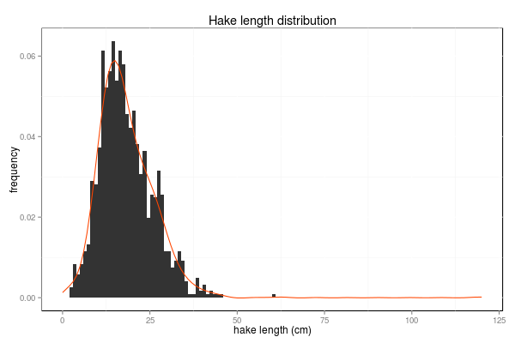
Fig. 4: Hake length distribution in the stomach content of te total dolpins analysed. Kernel probabiliy density funtion (red line).

However, since dolphins prey on the small hakes, usually on recruits less than one year old,
is expected that the length average and the distribution of the preyed hakes varies along the time. Analisys of the length distribution and estimation of their associated density function was conducted for each quarter of the year. In Fig. 5 distribution change throughout the year where the smaler hakes are found in the thirth quarter, corresponding with the period after the higher peak of the spawning, them average of the distribution increases along with the growth of hake. However, although trend is quite clear, the dispersion is high, likely because the European hake spawning is not concentrated in one year period.
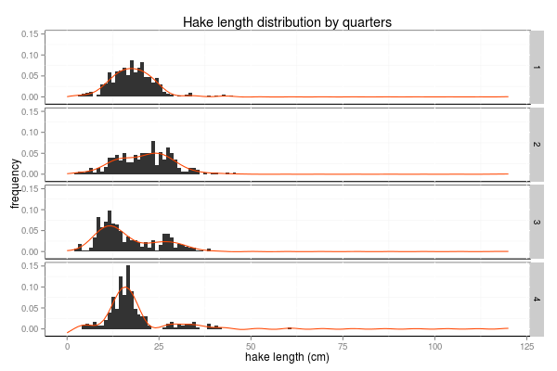
Fig. 5: Hake length distribution split by quarters. Histogram of length distribution of each quarter and probability density function.

As the hake distribution, abundance of hake susceptible to being preyed may vary throughout the year. In Fig. 6 box plots of relative abundance of hake (in number), in dolphins stomach are shown below the histograms of hake distribution. Total weight is shown in the right plots as well. Also in this graphics we can see, as the length distribution, abundance is not the same throughout the year.

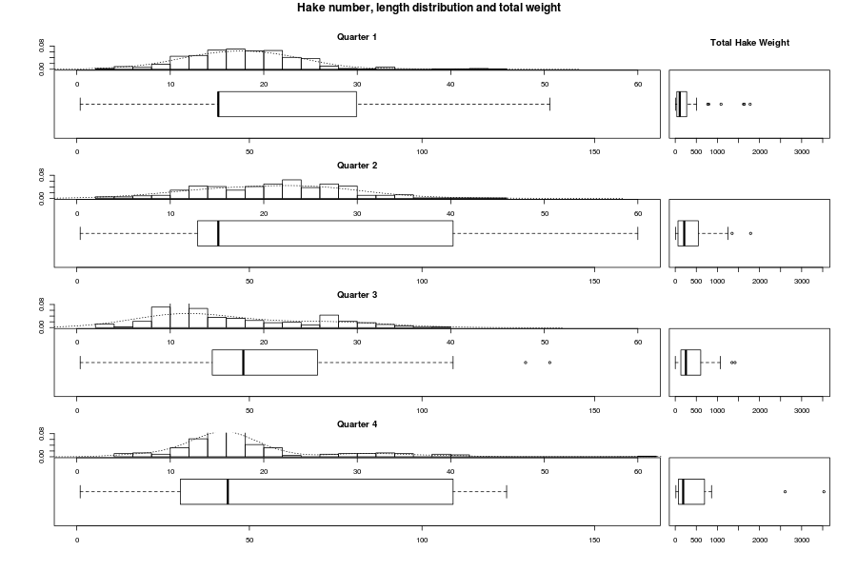
Fig. 6: Length distribution of hake in dolphin stomachs (histogramas), mean number of hakes per stomach (left boxplots) and their corresponded weight (right boxplots). All these data divided by quarters.

Average proportion of hake in dolphins diet has been calculated more accurately by conducting bootstraps for the mean. 95% confidence intervals were bootstrapped in the same way as well. In Fig. 7 proportion of hake with 95% CI are presented for each quarter for both sexes and as well as for males and females individually. The maximum consumption occurs in the second quarter but in the third and fourth show an opposite trend, increasing in males and dropping in females.
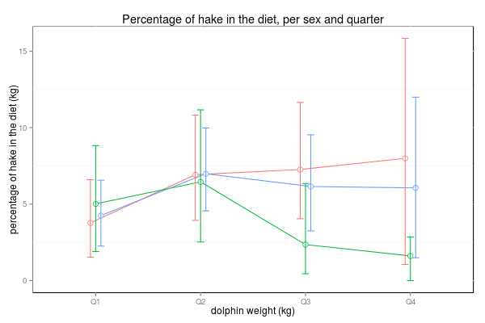
Fig. 7: Percentage of hake in dolphins diet and 95% CI. Consumption divided by quarters and sexes. Both sexes together (blue line), males (red line), females (green line).

